  Who we are!
  Ammarco is only one of its kinds, sole entity having its associated network in Islamabad, established and registered with Government of Pakistan.
  Ammarco gratifies itself in bringing in its professional services for interior & exterior design consultancy, planning and execution of business & residential projects. Equipped with specialized and experienced team of technical staff; Engineers, Sub Engineers, Electricians, Plumbers, Painters, Masons and Labor.
  Objectives
  - To be the strategic associate of our valued customers.
  - To provide value added services for the most feasible, cost effective and profitable projects.
  - Bring in widespread resources to each project.
  - To go the extra mile to ensure clients’ satisfaction – every time!
  - To furnish adaptable services drawing across divisional lines.
  
  Quality and Durability wrapped in a combination of Archetypal Contemporary designs – brought to you through examplary professionalism..
  Contact us
  Plot # 13, Shop # 04, I&T Centre, G-9/4, Islamabad.
  Phone: +92 51 2281133, 2325443
  Cell: +92 333 5766744
  Email: ammarco.pk@gmail.com
Interior & Exterior Design  Ammarco is a contracting firm in this business, our Executive and Technical Experts have already handled a vast range of Projects including, Group housings of public sector, Schools, Hotels, Industrial and Commercial buildings etc. Resulting in requisite experience for execution of all types of works. Equipped by sufficient tools, plants and workforce to cater the projects. We are financially sound and enjoy the good support of Leading Manufacturers and Dealers in the respective trade.  We provide the best price sensitive and quality oriented services using dedication as our tool to ensure quality.  Interior Design Services  Ammarco deems that interior of your Premises should manifest an expression as your signature. The spaces we design profess your personality, class, taste and grandeur.  Exterior Design Services  We are providing appropriate services rendered by a team of adroit professionals in order to guarantee the fabulous impression of your facade.  - Landscaping  - Gardening |  |  |  |  |  |  | Interior Work Details  Exterior Work Details
   | Flooring (Ceramic tiles, Wooden, Vinyl, Marbles & Granite)  False Ceiling work (Gypsum sheet, P.O.P & M.D.F)  Window Coverings, Anti-Shatter films, Blinds, Curtains  Glass & Aluminum, Partitions, Doors, Windows  Kitchen Pantry, Cabinets & Cupboards, Termite Proofing  Paint, Wall Graphy, Wall paper, Wall grace  M.D.F Partitions, Claddings, Joinery & Carpentry, Booth exhibition, Space Planning
    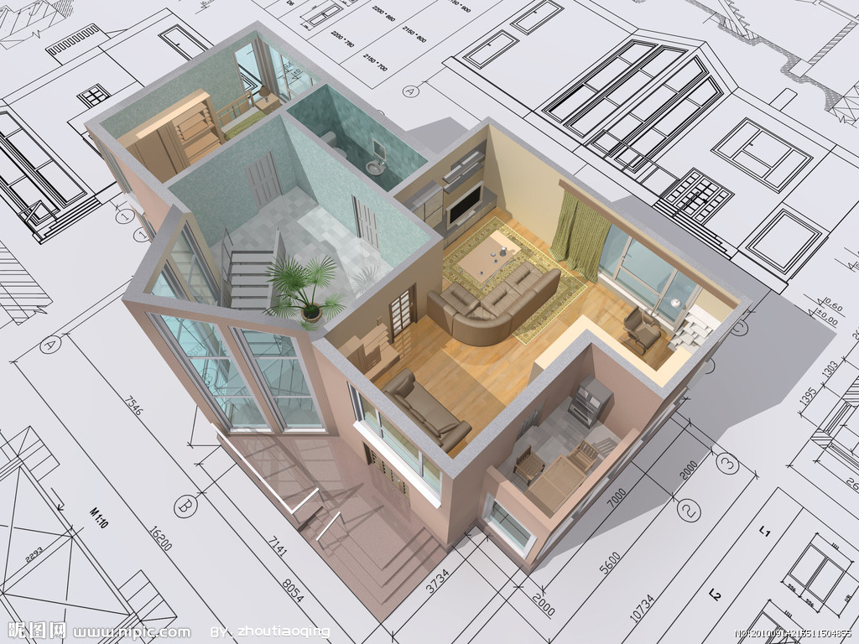
   | Aluminum Sections composite paneling,  Front Glazing, Signboards, Pena flex, Louvers Shutters,  Security Grills, S.S railing
    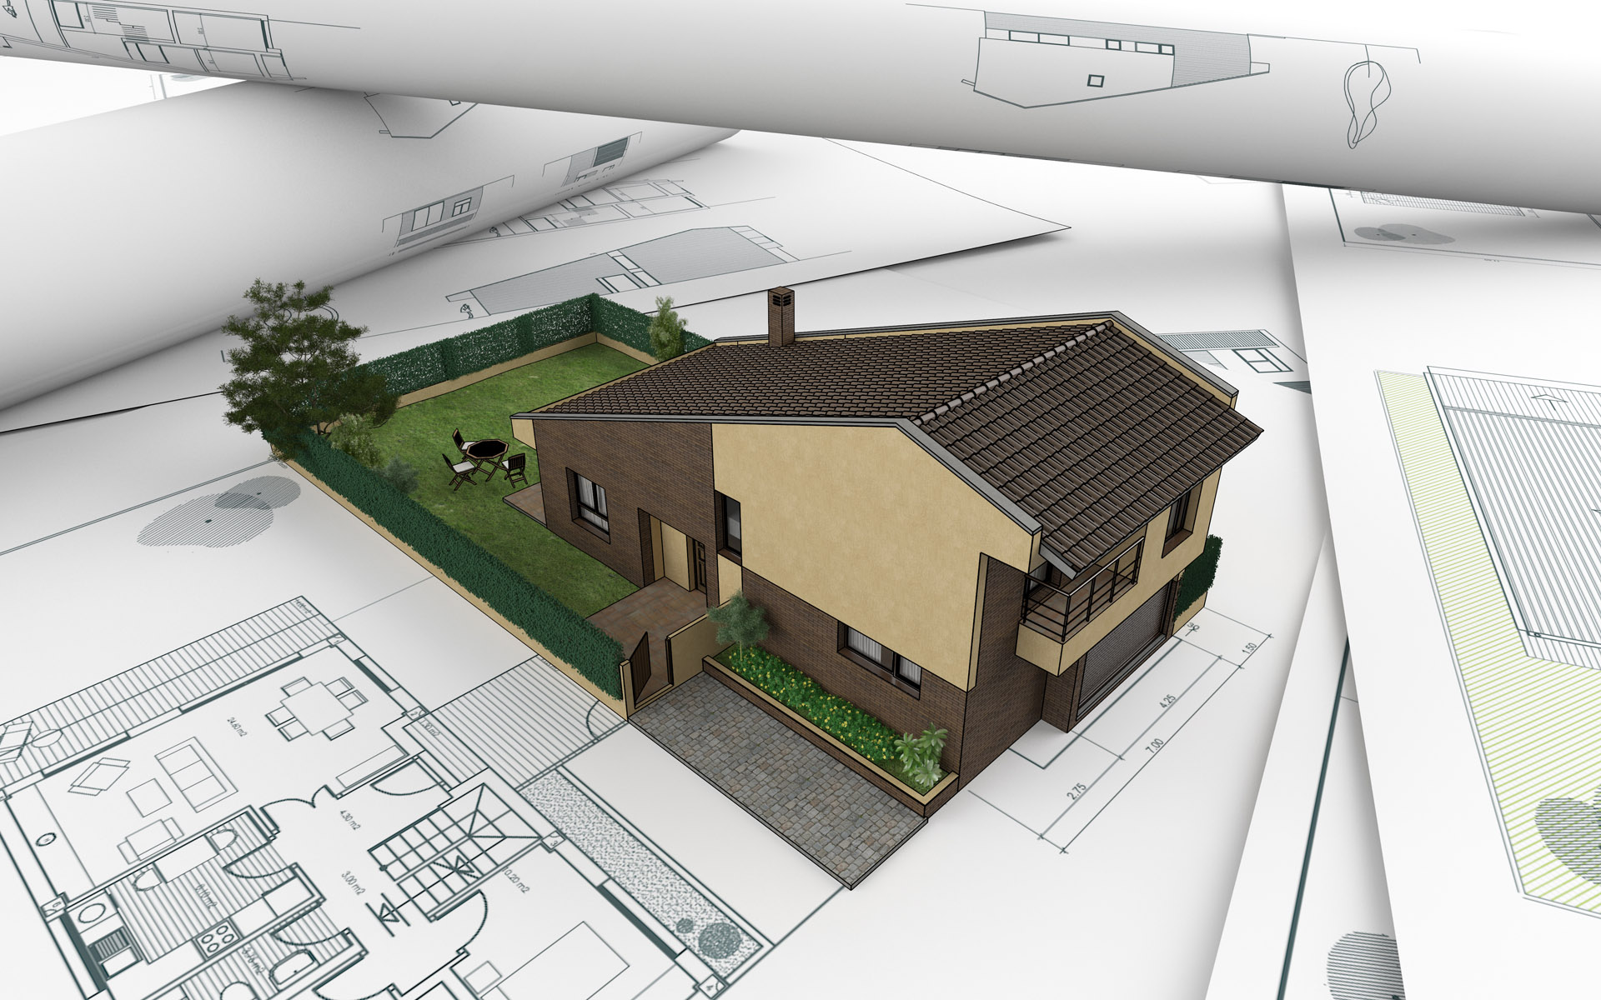
Civil Works  Ammarco is actively engaged in Civil Construction Works for our valuable clients. These services are rendered by our team of skilled and qualified engineers. We use superior grade materials and latest technology machines while rendering these services. Our quality controllers supervise the entire process in order to ensure the first class quality. We offer construction of modern & institutional buildings, hospitals, parking areas, malls, celebration & event halls and so on..  Electrical Works  Electrical fitting services that we offer to various commercial and residential sectors are provided according to clients’ projects’ requirement. We use excellent quality electrical fitting materials & items that are procured from authorized and quality driven vendors. Services are offered after complete planning and designing of working modules.  Plumbing Services  Plumbing services that Ammarco offers to our esteemed clients include various kinds of sewer and drainage pipe fittings and setting up septic tanks, manholes and many more. Operational inspection of undertaken projects before handover with complete satisfaction.  Horticulture Services  These services include improving the fertility of soil by using several kinds of Techniques and biodegradable composts. Ground leveling for landscaping and executing garden and farm related tasks. |  |  |  |  |  | Civil Work Details
  Electrical & Plumbing Work Details | Excavation, Dismantling, P.C.C, R.C.C, Precast Lintels, Brick and Block Masonry, Plaster, Paint  Counters, Vaults and Lockers, Roof Insulations, Seepage Treatments, Interlock Pavers  Internal wirings, Light circuits, Power switch sockets, Floor Box, Fittings & Fixtures, Power cables, Telephone Systems, Earthing  UPVC & PPR piping, Ceramic ware, Vanity, Sinks, Hand basin, Fiberglass Tanks, Water Pumps,  Sprinklers, Surfing, Seasonal & Evergreen plants, Grass
    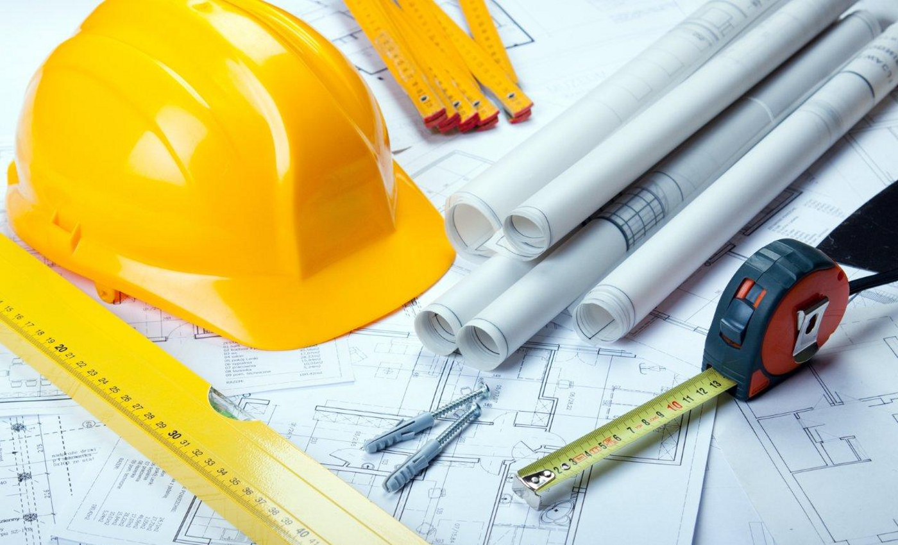
    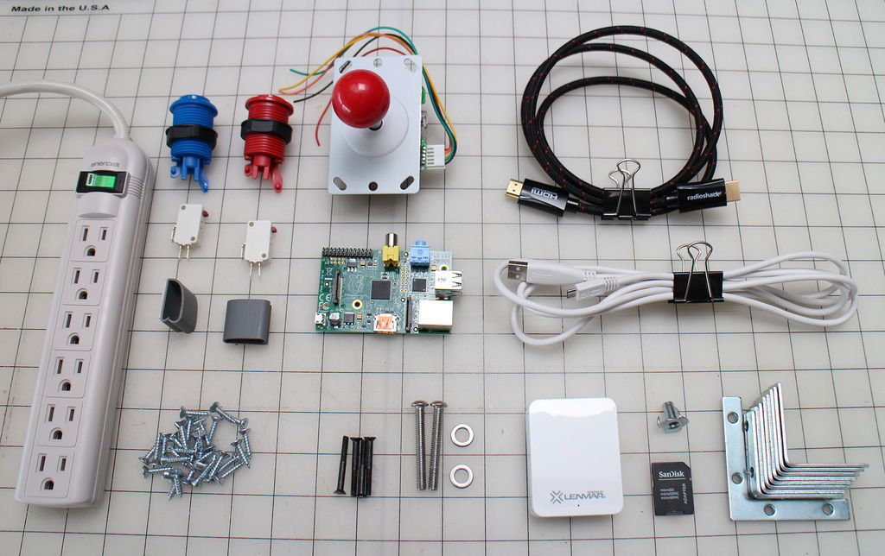
We can help you in!  Fabrication  We are enthusiastically engaged in offering our valued clients services of Fabrication works. Our professionals guarantee highly reliable and cost-effective solutions. Advanced machines and quality raw materials are used while undertaking our fabrication works. Apart from this, these services are delivered to the clients within the time frame.  - M.S Fabrication Works  - S.S Fabrication Works  - Aluminum Fabrication Services  - Pre Structure Fabrication Services  - Signage  Installations & Commissioning  Supported by an adept panel of certified professionals, our firm has gained excellence in provisions, installations and commissioning of equipments. We execute these services as per the specific requirements of our clients. |  |  |  |  |  | Fabrications Work Details  Installations Work Details
   | Staircase, Step-Ladders , Railings, Barriers, Fences, Grills, Shutters, Barb wires  S.S Logos, Signboards, Signposts, Road Signs, Indicators  Sunshades, Canopies, Warehouses, Roofs, Sheds  Overpasses, Suspension Bridges, Viaducts  Racks, Shelves, Bracket Frames, Casings, Cabinets, Cupboards  Towers, Supporting Structures
    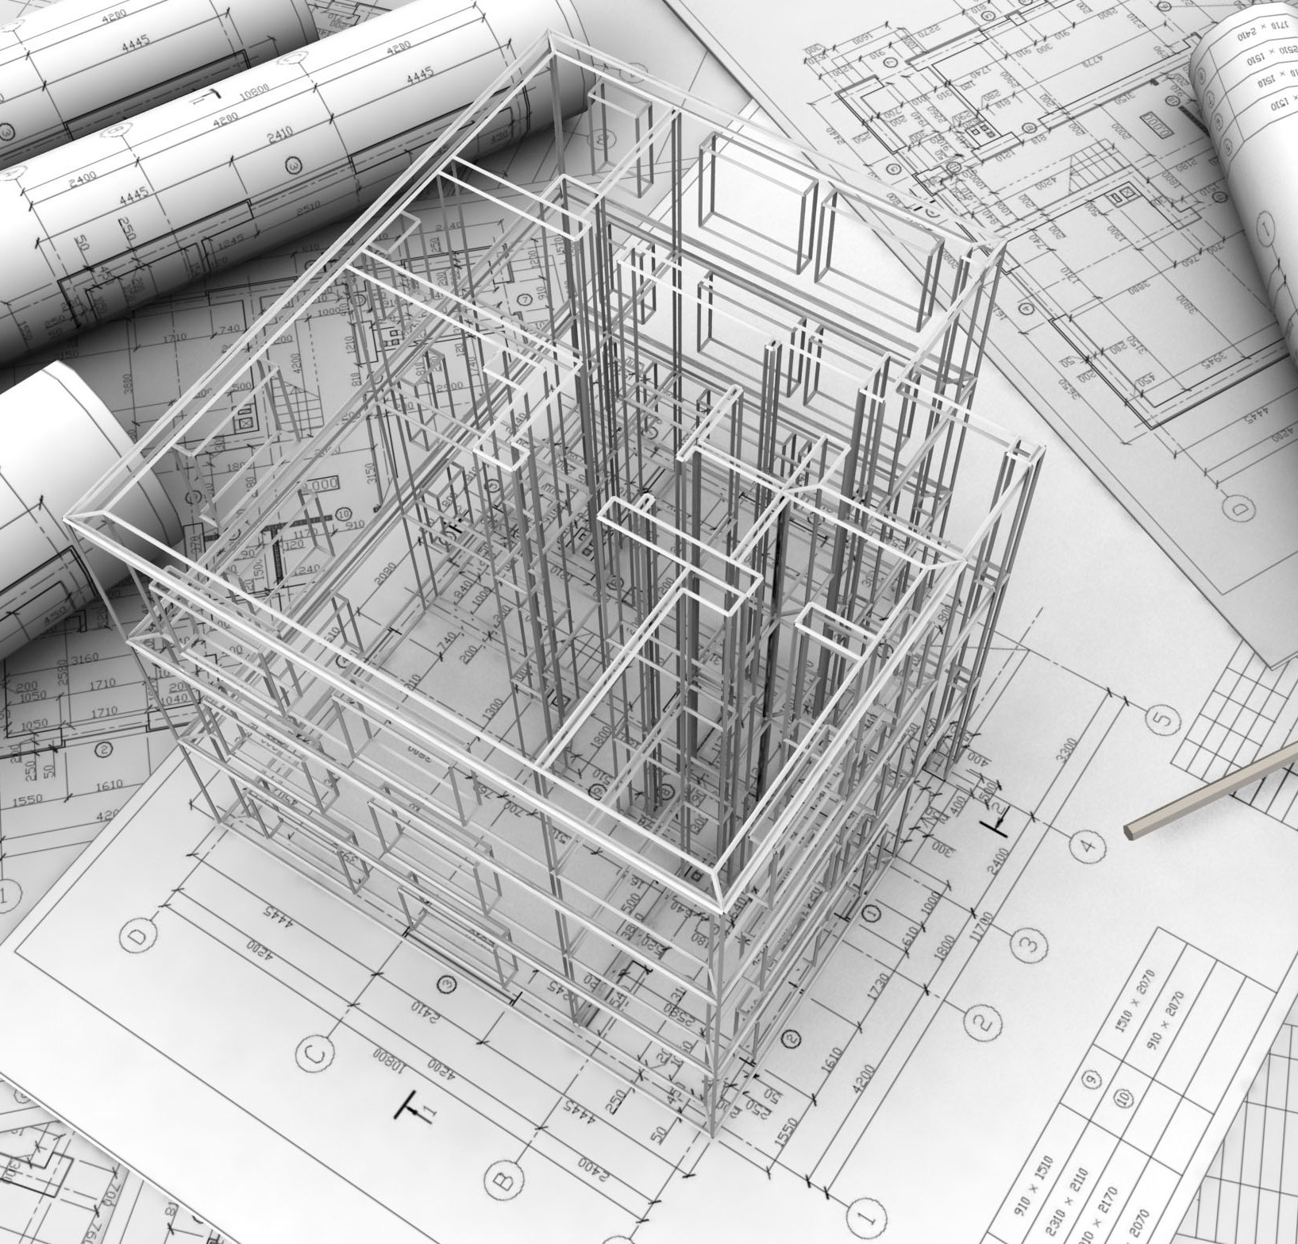
   | - HVAC  - Firefighting & Panic Alarms  - CCTV  - Security Alarms  - Solar Panels  - Generators & UPS  - Data and Voice Networking  - Distribution Switchgears & Control Panels  - Communication Racks/ Data Cabinets
    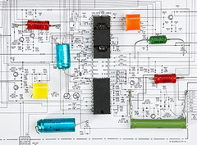

Accreditations  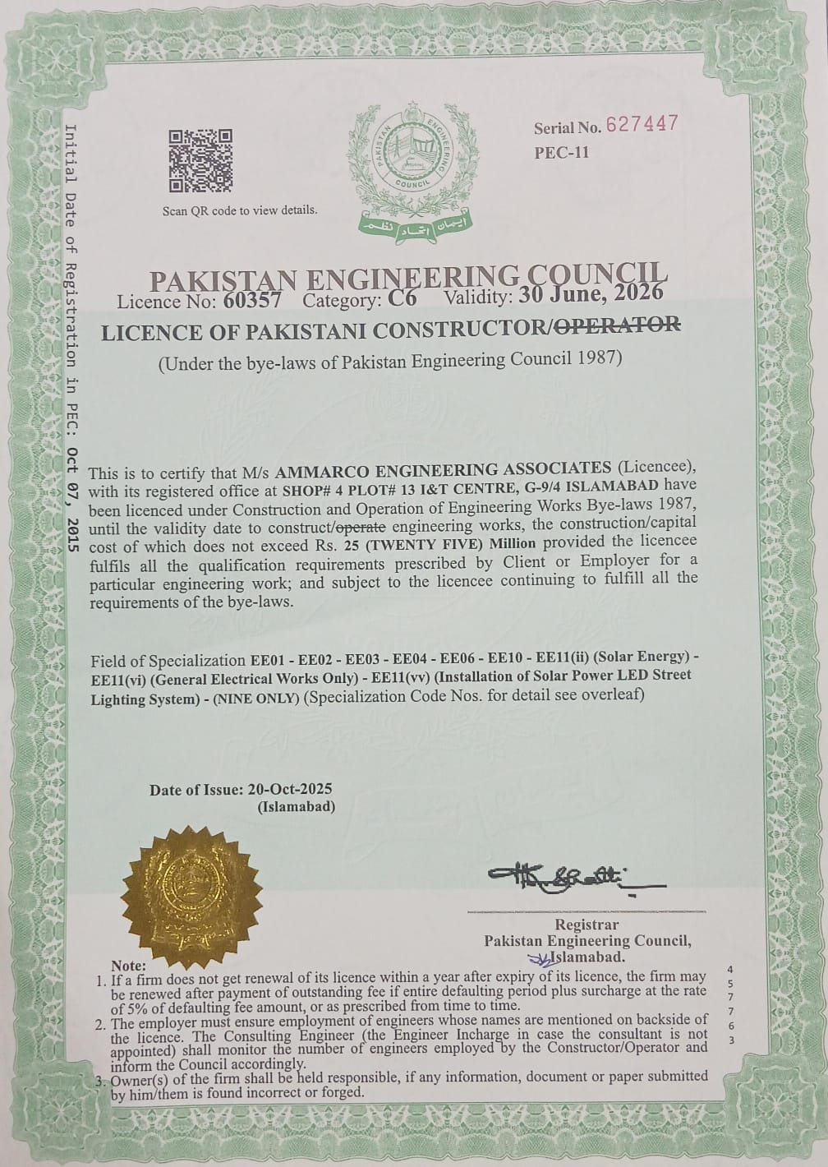 |  |  | 